XML

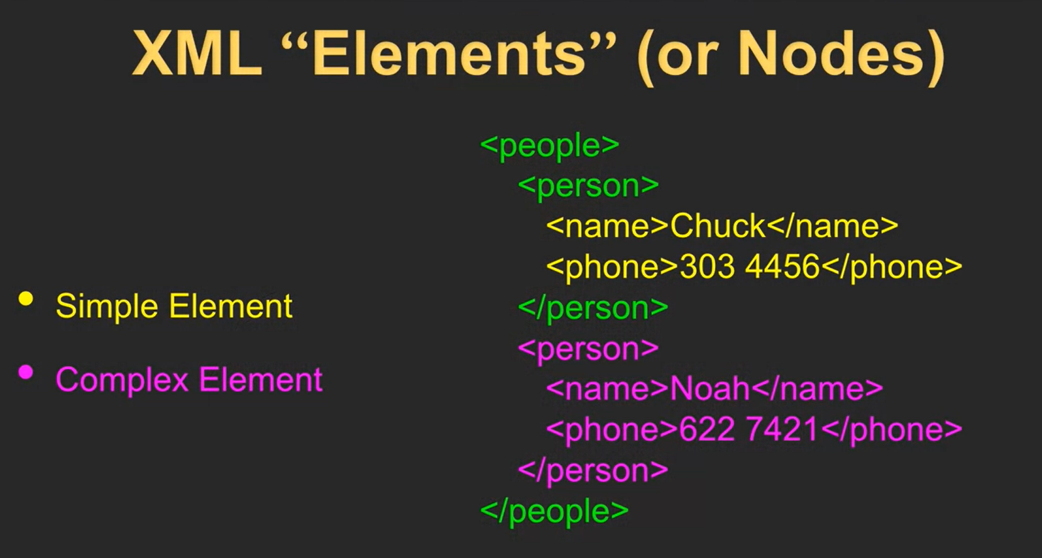

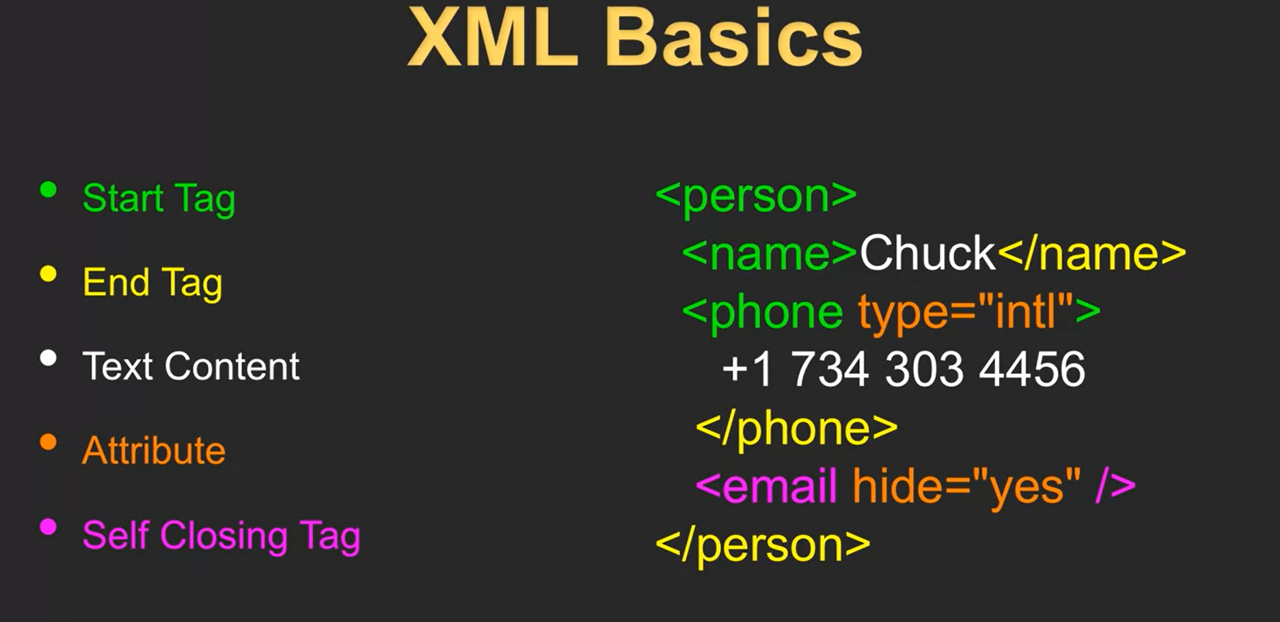

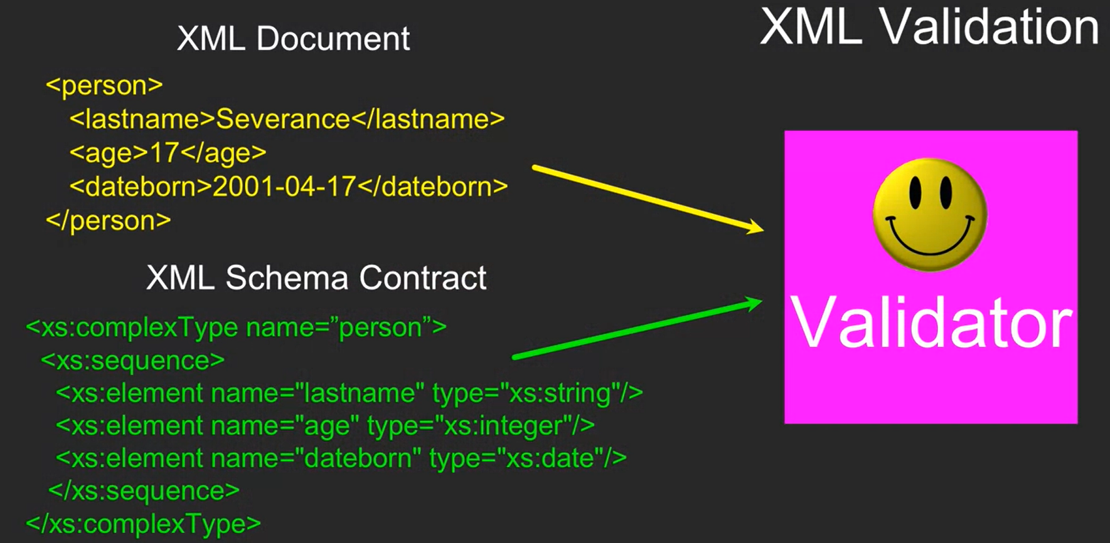

**Xml IN Python**

Making a tree of the XML data

